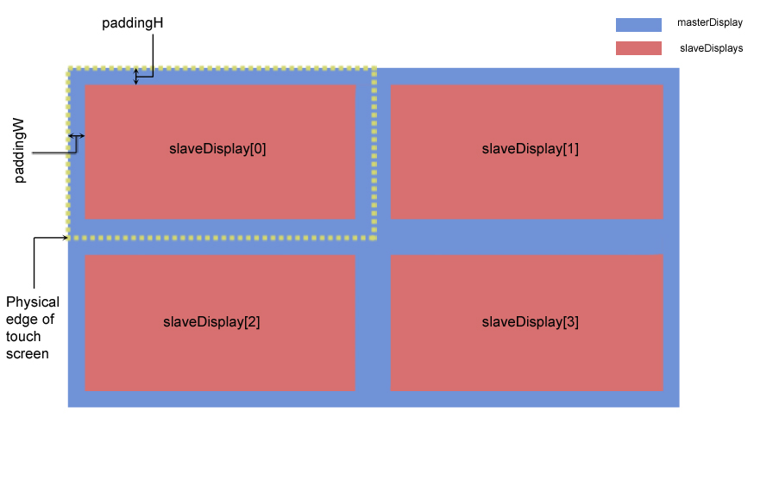Figure 1

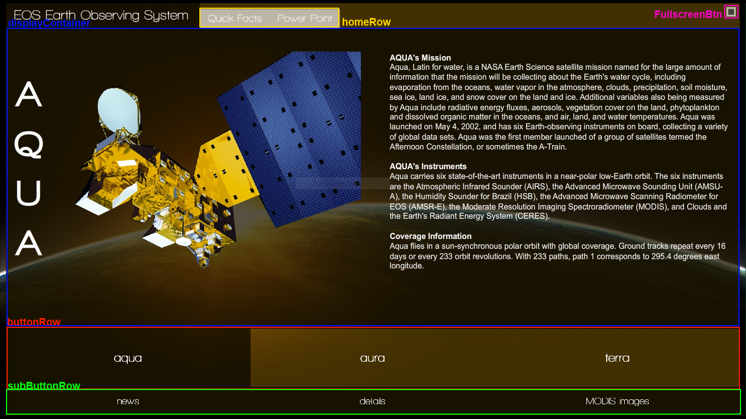Figure 2

IN GENERAL
Hallway.as is the main file. It contains the code that sets up the framework and the main page. All the other pages are added as modules from Hallway.as.

HOW DO I ADD ANOTHER SATELITE?
Create a new AboutText library symbol in the library

In Hallway.as add the new satellite to the “sats” array.

In bigButtonClicked handler add a new entry in the else if statement for the new satellite

//add handlers for the subButtonRow
subButtonRow.changeSat("yoursatname",yourSatNames,yourSatHandlers);
//load your newly created AboutText library symbol
dc.changeContent(new YourSatelliteAboutText());

HOW DO I ADD ANOTHER SLAVE DISPLAY (ANOTHER SECTION TO FLOAT TO)?

In the Hallway.as constructor, under the comment “slave displays”, you'll find the for-loop that populates the slaveDisplay array. Increasing the amount of times it loops will add more displays to the array.

for(var a:Number = 0;a<4;a++) { //change the “4” to how many displays you want
//random color
var sd:MovieClip = new MovieClip();
var color:uint = Math.random()*0xFFFFFF;
Utils.drawHitBox(sd,slaveW,slaveH,color,.3);
slaveDisplay.push(sd);
masterDisplay.addChild(slaveDisplay[a]);
}

After that, underneath the for loop is the code that positions each of the displays. Position the newly added displays in a similar manner. See the FIGURE 1 for information about the positioning variables and how they relate to the screen.

//position slave displays
slaveDisplay[0].x = paddingW;
slaveDisplay[0].y = paddingH;
slaveDisplay[1].x = slaveW + paddingW*2;
slaveDisplay[1].y = paddingH;
slaveDisplay[2].x = paddingW;
slaveDisplay[2].y = slaveH + paddingH*2;
slaveDisplay[3].x = slaveW + paddingW*2;
slaveDisplay[3].y = slaveH + paddingH*2;
//.. and so on

HOW DO I ADD A TAB BUTTON TO THE TOP ROW?

HOW DO I ADD A SATELITE SUB ROW BUTTON?

WHERE CAN I GET THE SOURCE CODE?

- The release DVD in the “source” directory

